Project Ananda Content

SECTION 1:

📸 Hero Image (Full Width)



H1 (Main Title):
Project Ananda
H2 (Tagline):
A space for Body–Mind–Emotion transformation
Subtext:
A structured wellness journey designed to bring your Body, Mind, and Emotions into balance — through movement, healing, awareness, and guided growth.
Statement (highlight strip):
This is not a fitness studio.
This is a space for alignment.

SECTION 2: ABOUT PROJECT ANANDA
H2: About Project Ananda
Content:
Project Ananda is Tattvam Niramaya’s signature transformation program, built for people seeking balance, energy, emotional clarity, and purpose.
Unlike generic wellness plans, we use a structured 3-Step Diagnosis System to understand where you truly are—before guiding you forward.
Every recommendation, session, and practice is personalized to you. Not one-size-fits-all.

SECTION 3: 3-STEP DIAGNOSIS SYSTEM
H2: Our 3-Step Diagnosis System
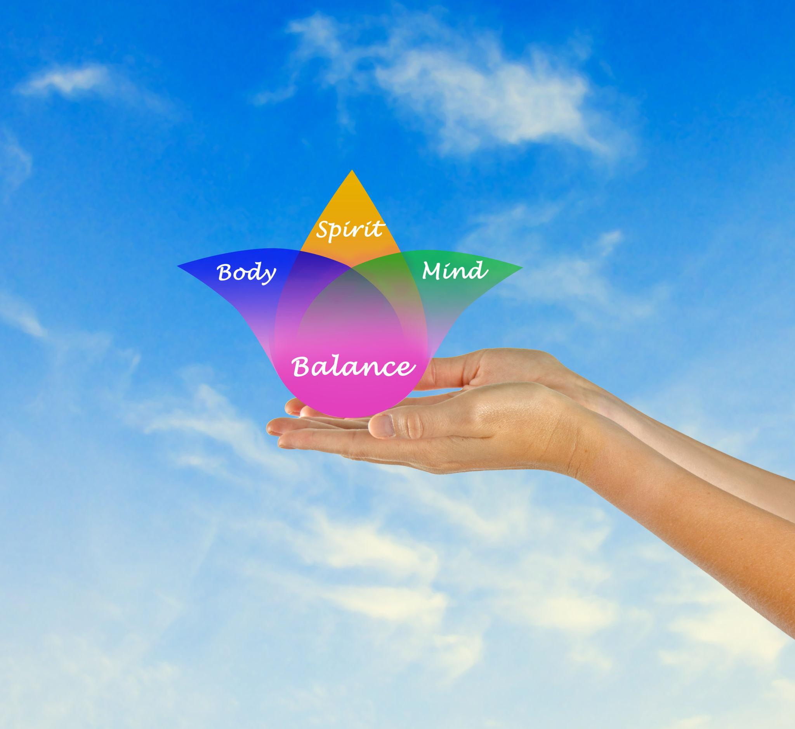

H3: 1. Body Analysis
Content:
We assess physical state, energy levels, flexibility, posture, sleep quality, and body type tendencies.
Purpose:
Understand what your body actually needs—not a generic plan.

H3: 2. Mind Analysis
Content:
We study reaction patterns, stress triggers, focus, decision-making, and daily responses.
Purpose:
Understand how you think and respond.

H3: 3. Emotional Energy Analysis
Content:
We identify emotional imbalances, blocked feelings, and energy flow patterns.
Purpose:
Uncover what’s held inside—so healing can begin.

SECTION 4: CHOOSE YOUR PATH
H2: Choose Your Path
(In this I want the 3 cards beside each other i.e. in 3 different columns)

🔹 CARD 1: ANANDA FLOW (Entry Level)

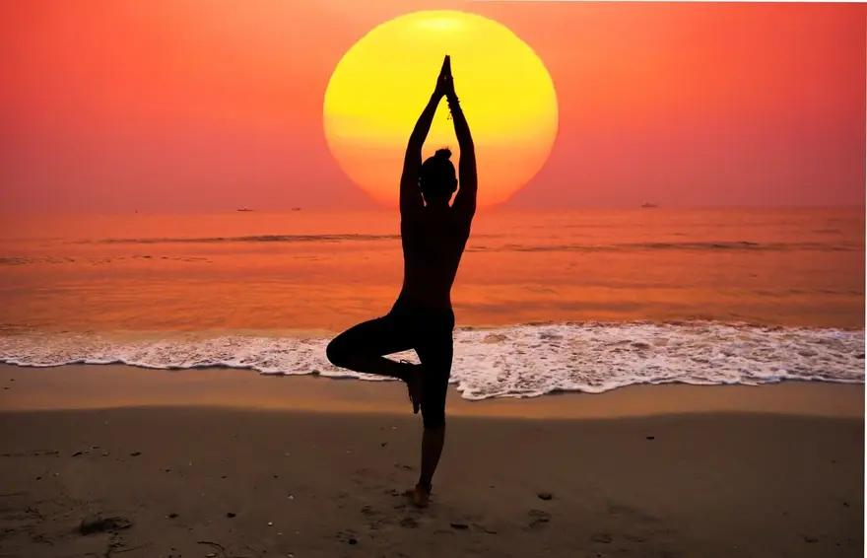
Short Line:
Get your body and energy moving
Includes:
- Daily Yoga & Kalari
- Group practices
- Trataka, Animal Walks, Laughter
- 1 Open Healing Session
- Community Day (optional)
- 3-Step Diagnosis
- Event access
Focus:
Discipline, consistency, movement
CTA: Enquire Now(Link this button to whatsapp number 6363606088)

🔹 CARD 2: ANANDA RISE (Most Recommended)


Short Line:
Shift patterns. Experience real change.
Includes:
- Everything in Flow
- Weekly Emotional Healing
- Personalized guidance
- Priority access
- Discounted events
Focus:
Body + Mind + Emotional transformation
CTA: Enquire Now(Link this button to whatsapp number 6363606088)

🔹 CARD 3: ANANDA INNER CIRCLE (Premium)

📸 Image



Short Line:
Your life, guided personally
Includes:
- Everything in Rise
- Monthly 1:1 sessions
- Personalized tracking
- Direct access
- Premium events included
Focus:
Deep, accelerated transformation
CTA: Enquire Now(Link this button to whatsapp number 6363606088)

SECTION 5: WHY PROJECT ANANDA WORKS
H2: Why Project Ananda Works
Content:
Real transformation happens when body, mind, and emotions work together.
Most people try to fix one part.
We align all three.

SECTION 6: WHO IS THIS FOR
H2: Who Is This For?
Content:
Bullets:
- Stuck in repeating patterns
- Low energy / inconsistency
- Emotional heaviness
- Mental overwhelm
- Feeling disconnected
- Ready for real change

SECTION 7: STARTER EXPERIENCE (FREE TRIAL)
H2: Starter Experience — Free Trial
Includes:
- 1 Physical Session
- 1 Mindful Session
- 1 Healing Experience
Perfect For:
Trying before committing
CTA: Enquire Now(Link this button to whatsapp number 6363606088)

